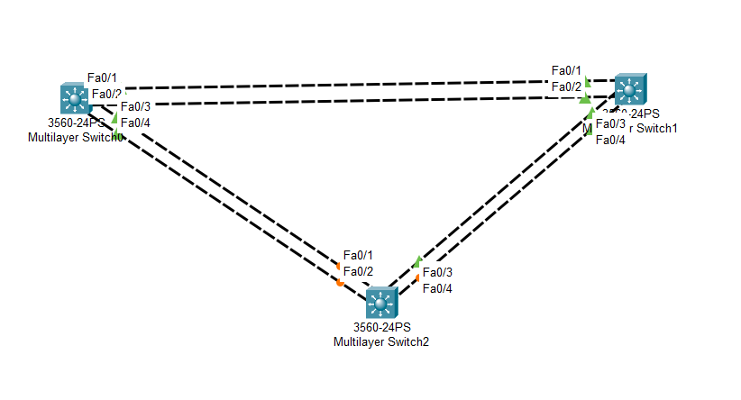

Task

1. Set HostName
2. Enable Password
3. Show Enable Password
4. Setting Ip Address
5. Setup Default Gateway
6. Make Telnet
7. Create Vlan

Switch1>en

Switch# config t

Switch1(config)# hostname SW1

SW1(config)# enable password Sifat

SW1(config)#end

**Show Enable Password**

SW1#sh running-config | include enable

SW1(config)#enable secret Cisco

**Setting Ip Address**

SW1(config)# int vlan1

SW1(config)#ip address 192.168.1.1 255.255.255.0

SW1(config)#no shut

Same for other Switch2 192.168.1.2 and Switch3 192.168.1.3

**Setup Default Gateway**

SW1(config)#ip default-gateway 192.168.1.100

**Same for other switches**

Show The Gateway address

SW1#Sh ip route

SW1#config t

SW1(config)# int range fa0/1,fa0/2,fa0/3,fa0/4

**Create Virtual Terminal Season There are 16 available 0-15**

SW1(config)#line v

SW1(config)#line vty 0 7

SW1(config-line)#password Sifat

SW1(config-line)#login

SW1(config-line)#end

**Delete Logged in information**

Clear line vty

**Create VLAN**

SW1#config t

Enter configuration commands, one per line. End with CNTL/Z.

SW1(config)#vlan 50

SW1(config-vlan)#name Vlan50